**Color Model in Computer Graphics** :

Additive Color Model Subtractive Color Model

| Additive Color Model | Subtractive Color Model |
| --- | --- |
| 1.**RGB**, **HSV, HSL** | 1.**CMY** , CMYK |
| 2.ACM generates color by adding multiple colors. | 2. SCM generates color by subtracting diff color. |
| 3.Active Display, monitors,phone screen | 3.devices which deposit color.  Printer, Copier. |
| 4. No data → Black | 4. No data → White |
| 5. Increase Brightness | 5. Decrease Brightness |
|  |  |
|  |  |

**RGB Color Model** →

R= Red, G = Green, B=Blue

**2^24** color combination model.

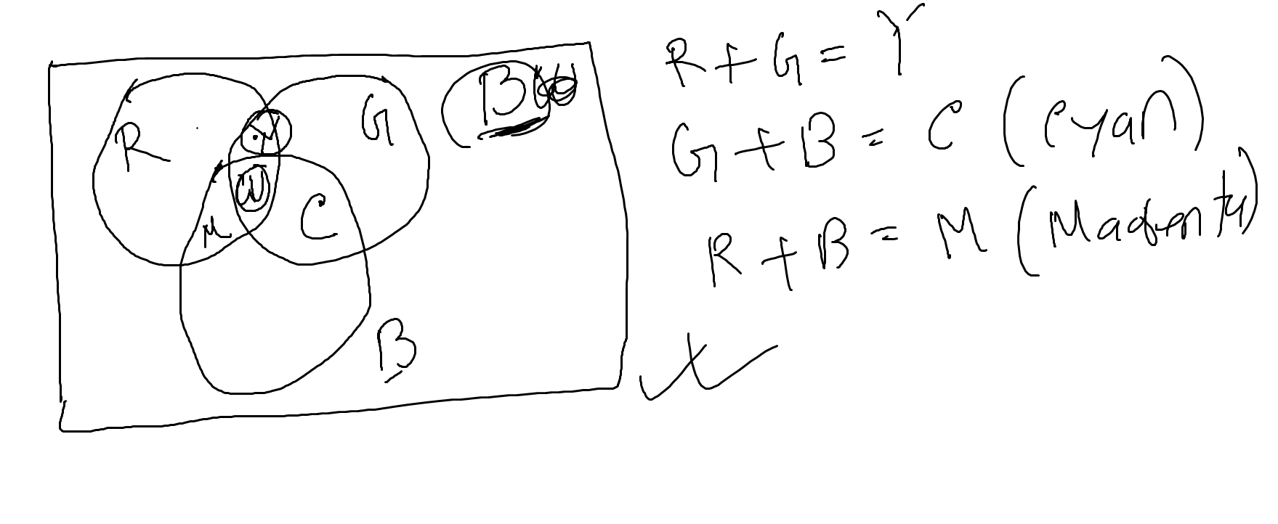

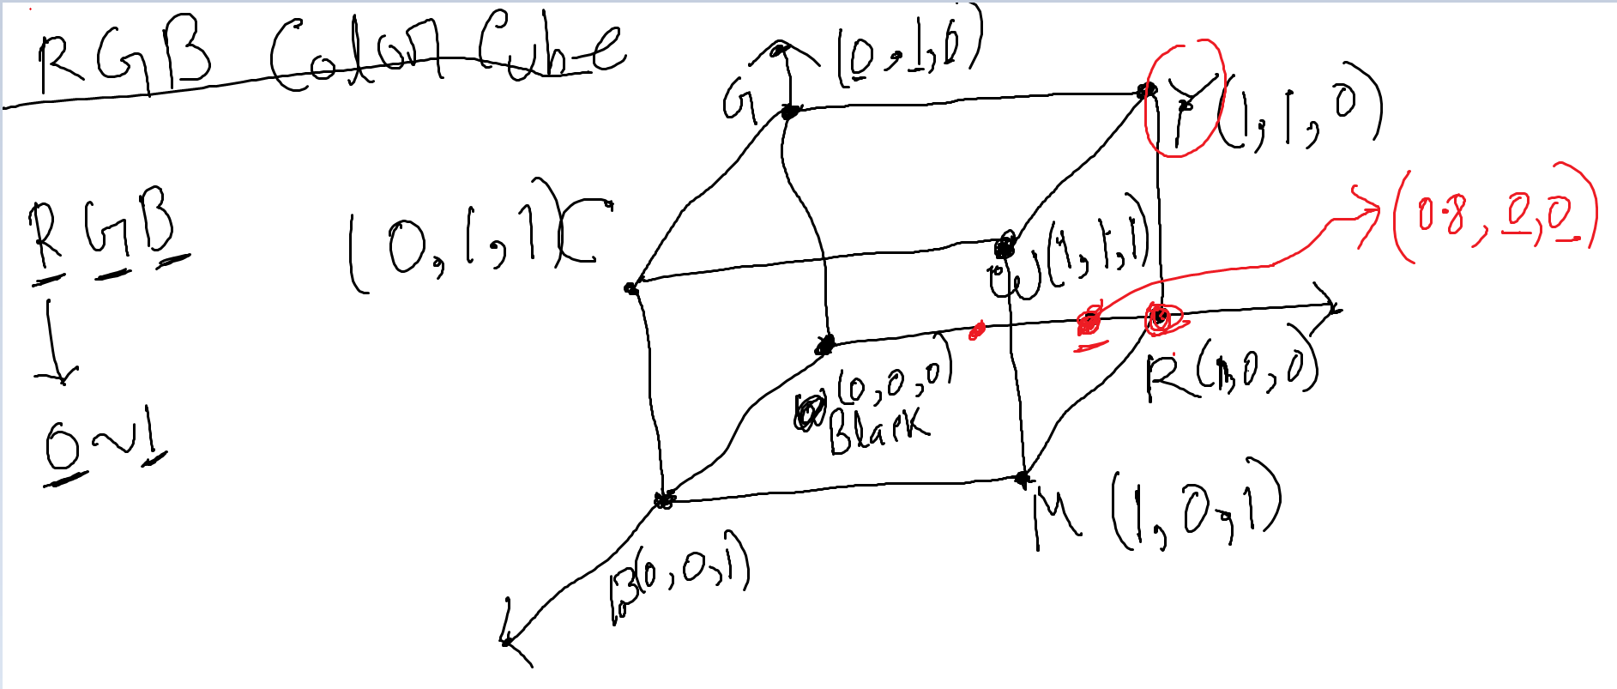

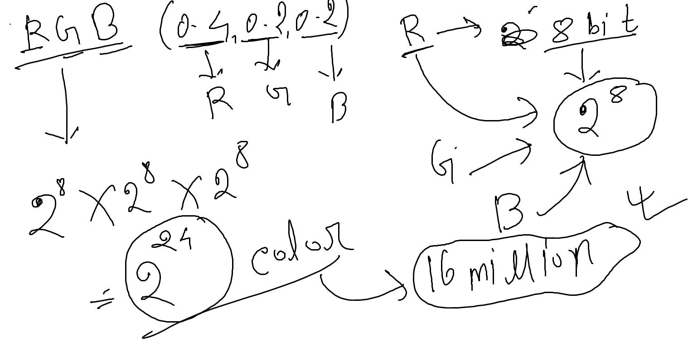

**CMY :** C= Cyan, M=Magenta, Y = Yellow

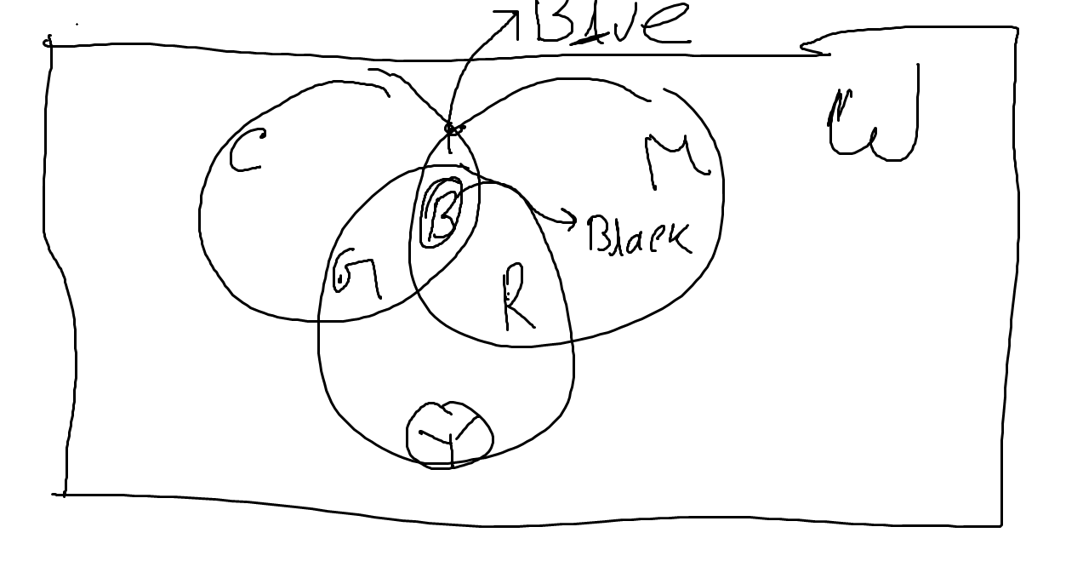

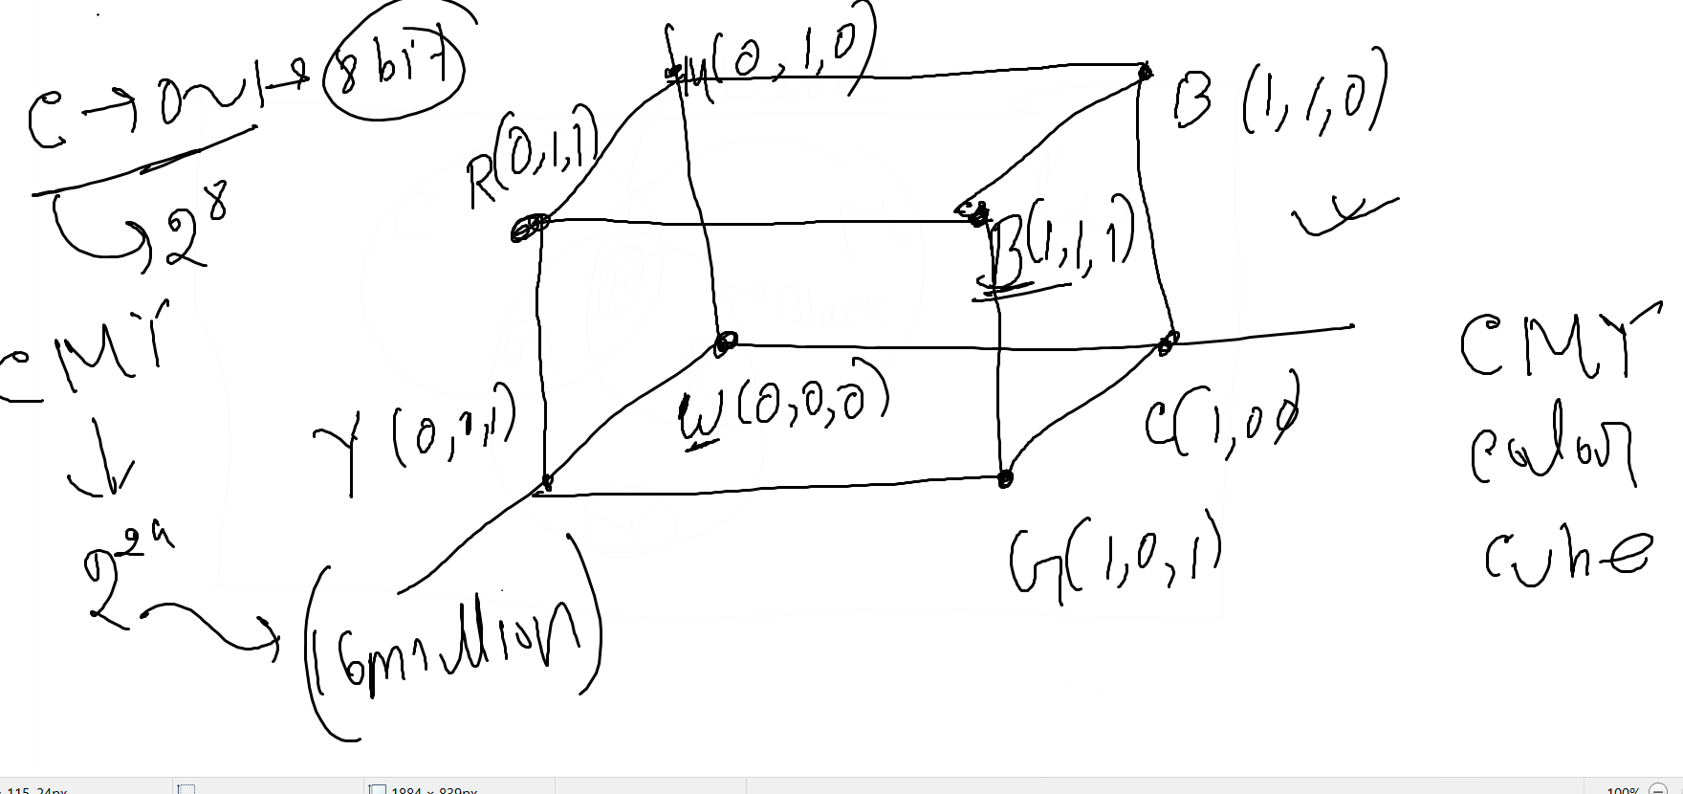

RGB to CMY conversion and vice-versa

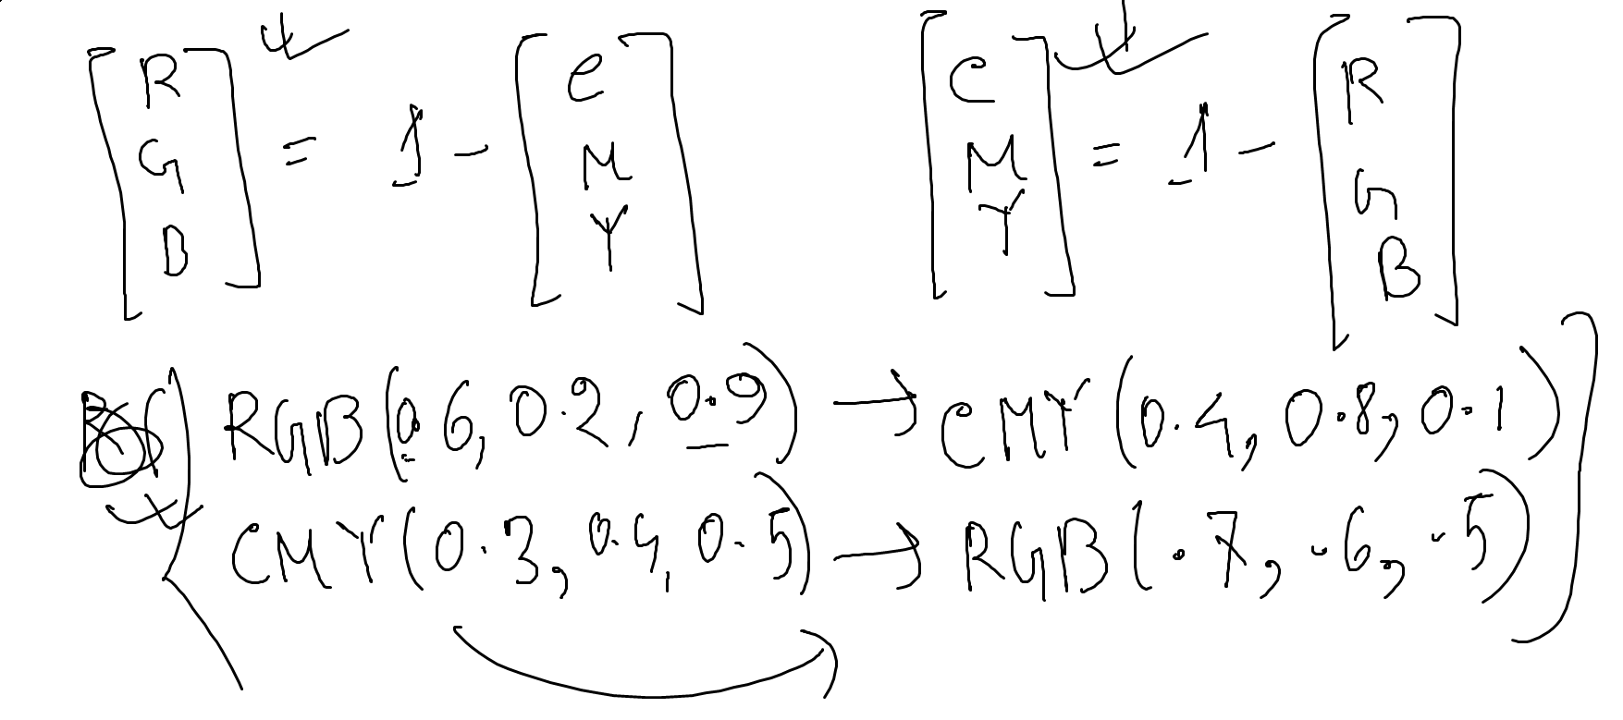

**HSL Color Model** :

H = Hue ( it actually helps us select the color) [0 degree - 360 degree]

S = Saturation (intensity of the color) [ 0 - 1 ]

L = Lightness (Background color) [0 - 1]

**HSV color Model :**

V = Value (Brightness) → works in conjunction with saturation and describes the intensity or the brightness of the model.